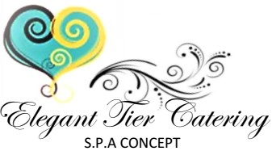

**PARTY FAVORS**

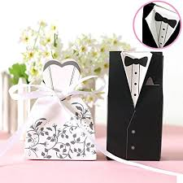

**PARTY FAVOR PRICING**

This assortment of wedding **dress** and **tuxedo party favor** boxes are just the thing for setting out guest favors at your wedding, shower, rehearsal dinner, women & men conference or a princess birthday party. Give your guess a token of thanks with a favor box filled with mints or chocolates specially décored by Elegant Tier Catering to match your event theme.

**Individuals**

.50 cents - each includes three edibles

**A Set**

.75 cents - each includes three edibles

Thank you for your interest & we look forward to serve you!